Game Design Document

Fill up the Following document

1. Write the title of your project.

The Stampede

1. What is the goal of the game?

The goal of the game is to help the player reach his home safe.

1. Write a brief story of your game?

When an ordinary man finishes his work and was returning home, he saw

Many people were packing their belongings and leaving in a hurry . The

Ordinary man asked a fellow person passing by who told the man that

There was a stampede going on .Help the man get to his home safely!

1. are the playing characters of this game?

* Playing characters are the ones which respond to the user based on the Which input from the user
* Cars, monkeys, dinos, wizards etc, are the playing characters in the game.

|  |  |  |
| --- | --- | --- |
| Number | Character Name | What can this character do? |
| 1 | The ordinary man | Walk and change routes. |

5. Which are the Non Playing Characters of this game?

* Non Playing characters are the ones which don't have an action or a behaviour when the user interacts with the game.
* Hurdles, stones, bananas, coins, etc are non playing characters in the game.

|  |  |  |
| --- | --- | --- |
| Number | Character Name | What can this character do? |
| 1 | Animals | Randomly appear from any route. |
| 2 | Birds and Insects | By touching the player, they reduce the player’s speed. |

Draw your imagination of this game. What does this game look like?

* Draw the game either on your computer or on paper,
* Add images of scenes of the game to show each of the playing and non-playing characters at least once.

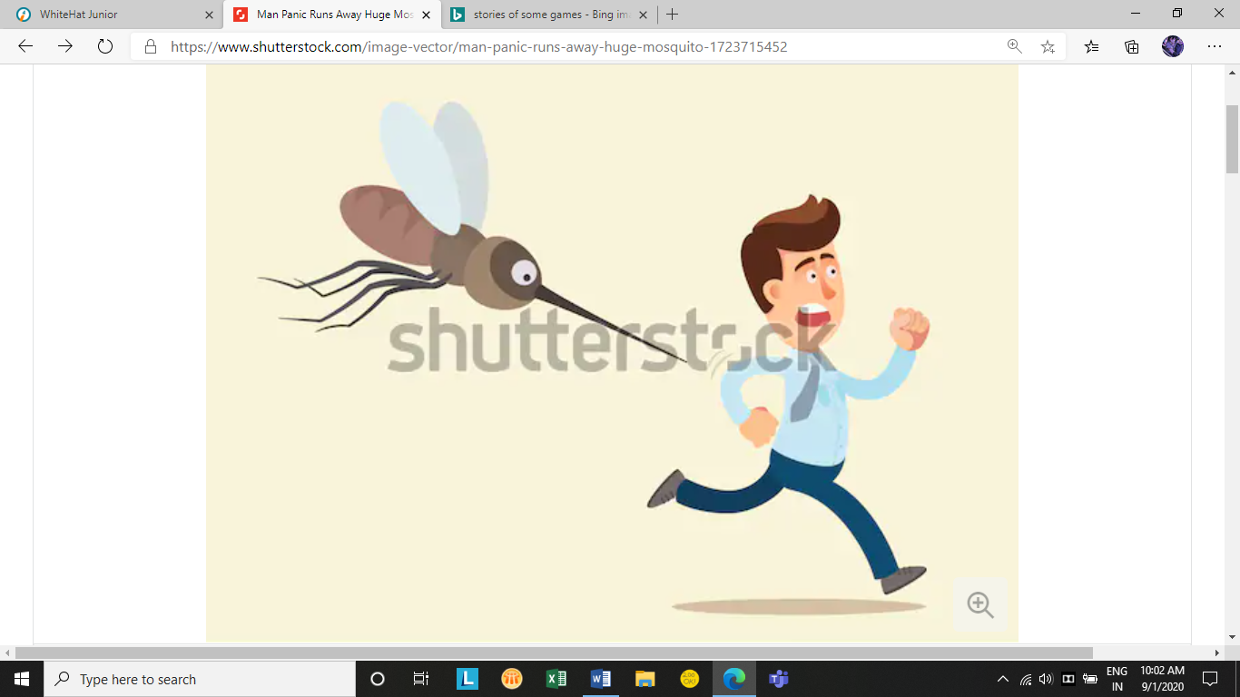

Man running away from insects.

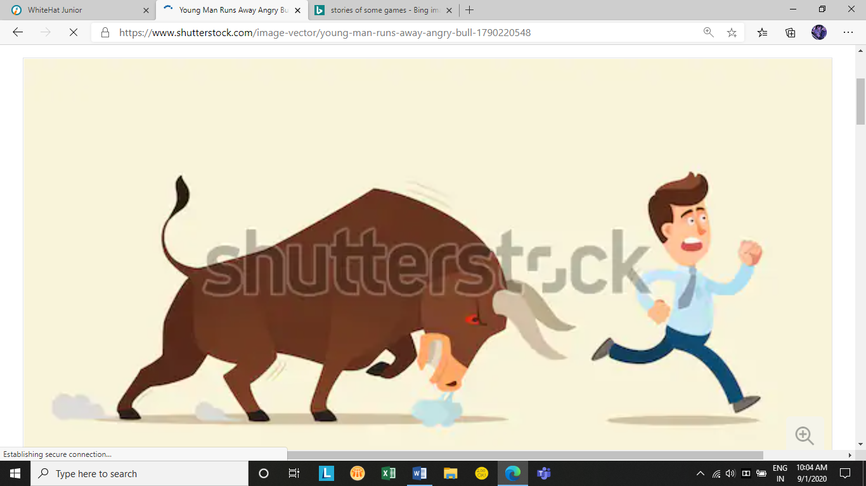

Man running away from animals.

How do you plan to make your game engaging?

The man will receive three chances to obtain his health but if the animals hit him continuously,

Then the game ends and the player loses. The speed of the animals shall be more than that of

The player. Also, the birds and insects will also reduce the speed of the player.